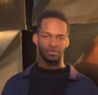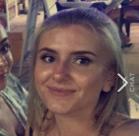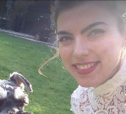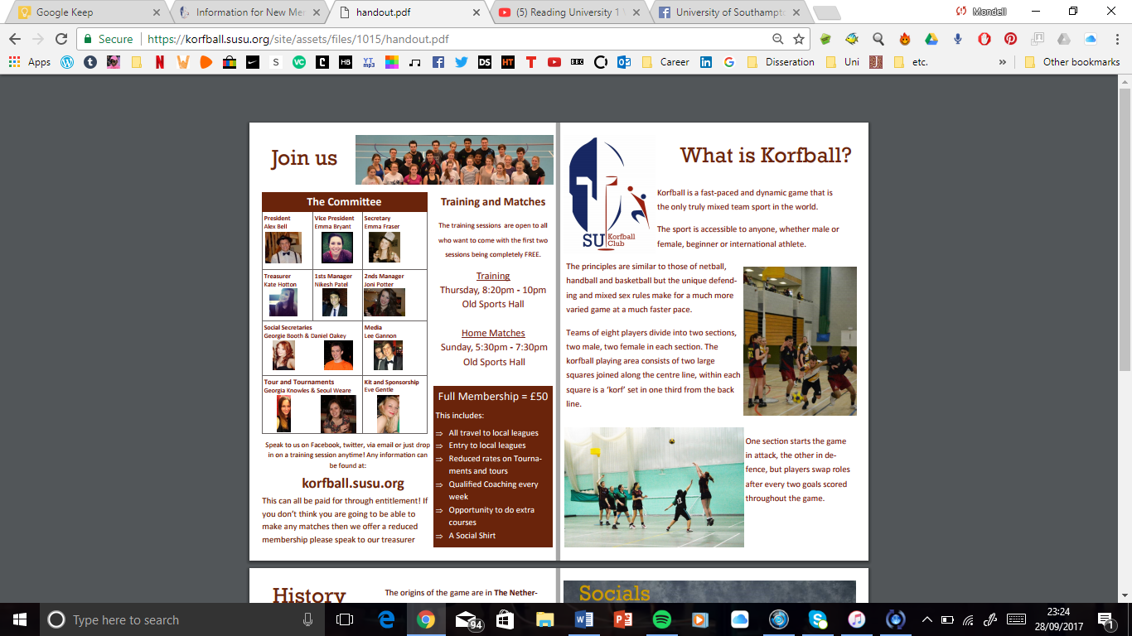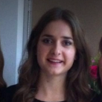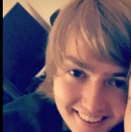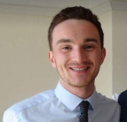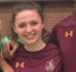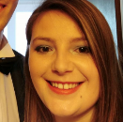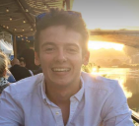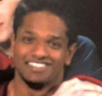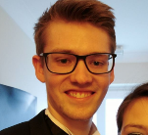

Keiron & Ben

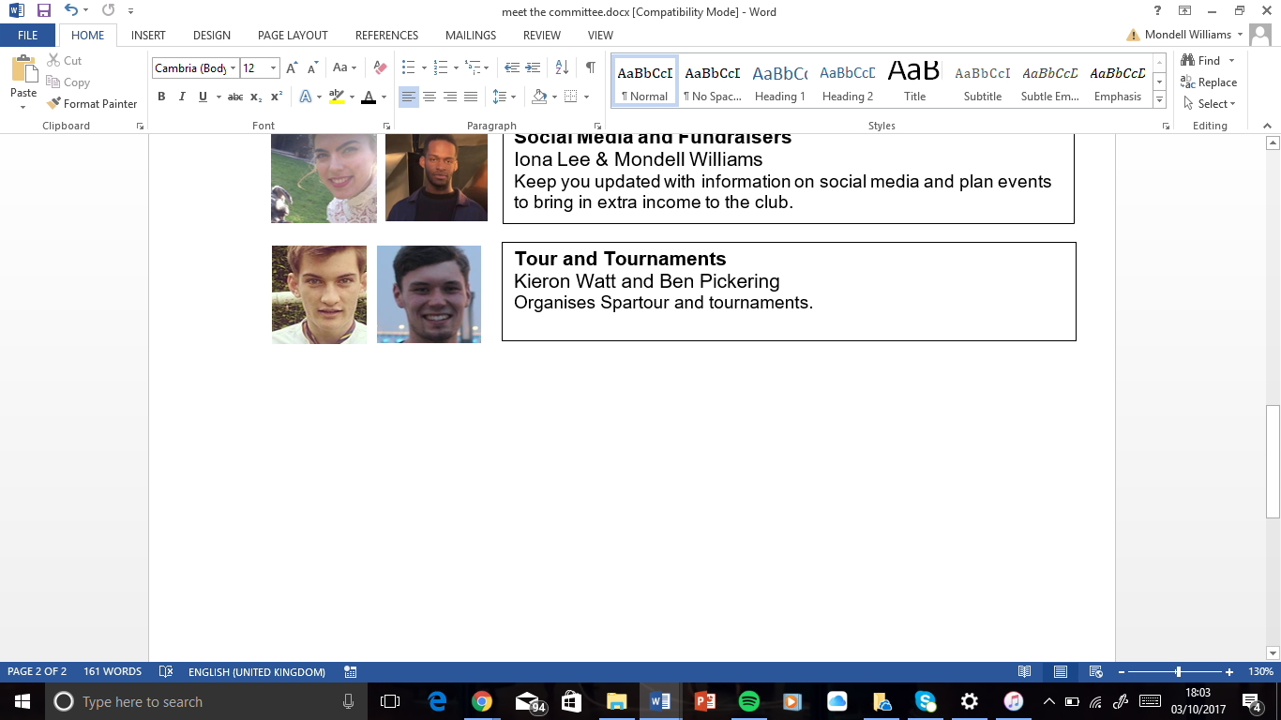

**Tour and Tournaments**

Iona & Mondell

Sara & Becky

Tom D

Catherine

Jack

Carensa

**Social Secretaries**

**Social Media & Fundraising**

Iona

Matt

Dinesh

Tom K

**Sponsorship**

**CAPTAINS**

**Third Team**

**Second Team**

**First Team Campaign**

**Secretary**

**Treasurer**

**Vice President**

**President**

**Training**

**Thursday 8:00pm – 10pm (Old Sports Hall)**

**Full Membership: £60**

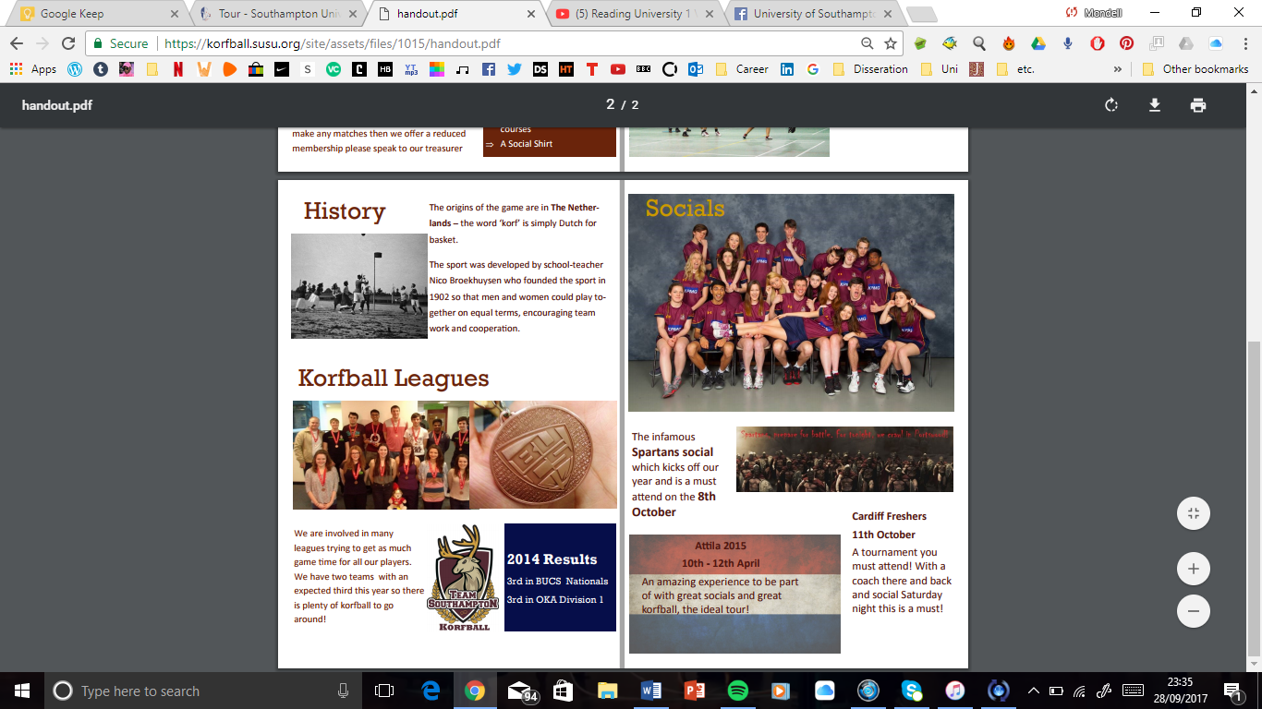

**Socials**

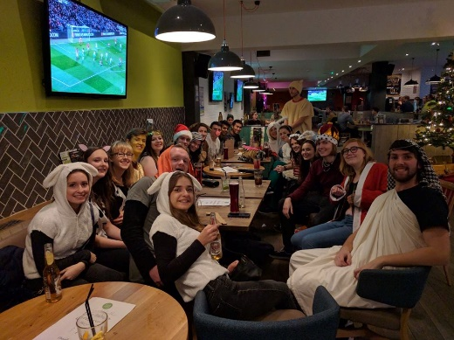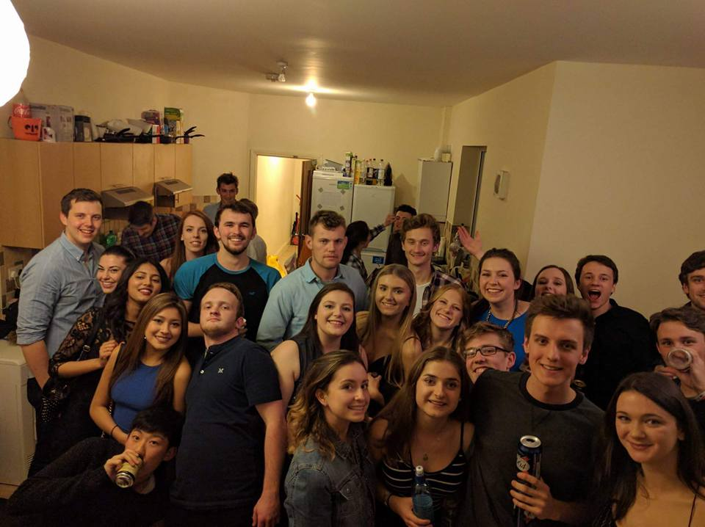

Throughout the year we organise a series of fun and engaging socials in order to consolidate our friendships and ease the stress of our studies. Our most memorable socials include the annual house crawl, Christmas dinner and beer pong where we occasionally join with other societies. We put on a mixture of both alcoholic and non-alcoholic socials (which include paintballing, movie nights and outdoor excursions).

**BUCKS Results 2015 and 2016**

(1st) Southampton First Team, National Champions